For our system, we will use theMVC or “Model-View-Controller”approach as there are many advantages of this approach compared with other approaches. Here’s how:

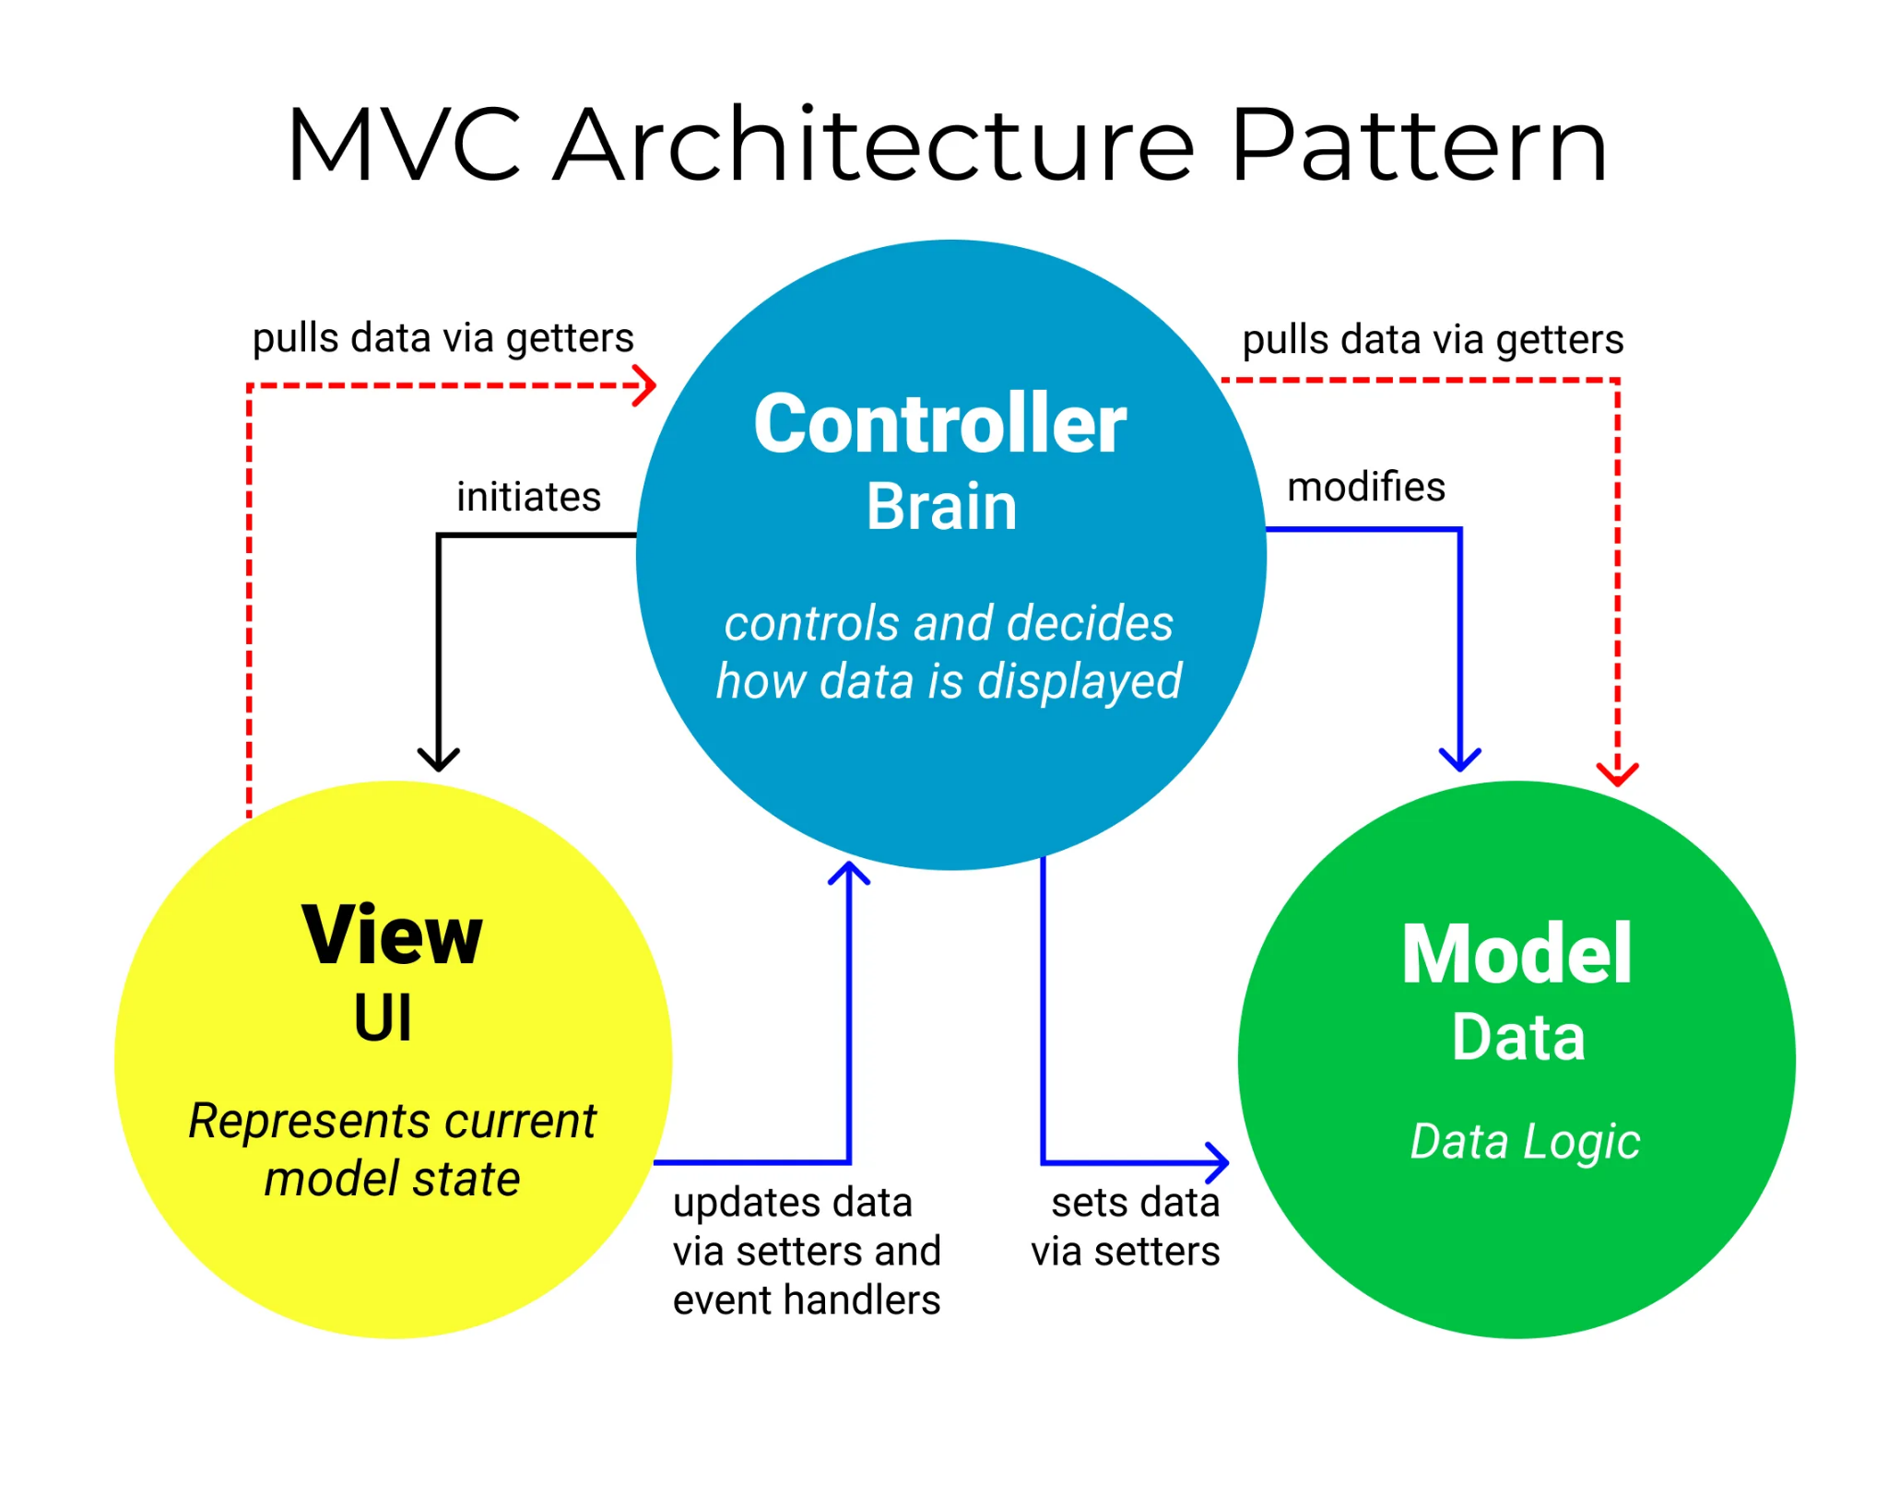

1. MVC’s 3 main components

##### Model: The Model component corresponds to all the data-related logic that the user works with. This can represent either the data that is being transferred between the View and Controller components or any other business logic-related data. For example, a Customer object will retrieve the customer information from the database, manipulate it and update its data back to the database or use it to render data.

1. View: The View component is used for all the UI logic of the application. For example, the Customer view will include all the UI components such as text boxes, dropdowns, etc. that the final user interacts with.

##### Controller: Controllers act as an interface between Model and View components to process all the business logic and incoming requests, manipulate data using the Model component and interact with the Views to render the final output. For example, the Customer controller will handle all the interactions and inputs from the Customer View and update the database using the Customer Model. The same controller will be used to view the Customer data.

1. Reasons why we choose MVC for our system?

##### Faster Development Process

MVC supports rapid and parallel development. MVC model allow separation between logic design and ux design, which make it possible that one programmer works on the view, one works on the controller transfer and the other can work on the controller to [create the business logic of the web application](https://www.brainvire.com/microsoft-enterprise-services/). Hence, the application developed using the MVC model can be completed three times faster than applications that are developed using other development patterns.

##### Ability To Provide Multiple Views

In the MVC Model, you can create multiple views for a model. Today, there is an increasing demand for new ways to access your application and for that MVC development is certainly a great solution. Moreover, in this method, code duplication is very limited because it separates data and business logic from the display.

##### Support For Asynchronous Technique

The MVC architecture can also integrate with the JavaScript Framework. This means that MVC applications can be made to work even with PDF files, site-specific browsers, and also with desktop widgets. MVC also supports an asynchronous technique, which helps developers to develop an application that loads very fast.

##### The Modification Does Not Affect The Entire Model

For any web application, the user interface tends to change more frequently than even the business rules of the [.net development company](https://www.brainvire.com/asp.net-development). It is obvious that you make frequent changes in your web application like changing colors, fonts, screen layouts, and adding new device support for mobile phones or tablets. Moreover, adding a new type of view is very easy in the MVC pattern because the Model part does not depend on the views part. Therefore, any changes in the Model will not affect the entire architecture.

##### MVC Model Returns The Data Without Formatting

MVC pattern returns data without applying any formatting. Hence, the same components can be used and called for use with almost no interface.

1. Specific description of MVC architectural pattern using diagram

<https://viewer.diagrams.net/?page-id=c4acf3e9-155e-7222-9cf6-157b1a14988f&highlight=0000ff&edit=_blank&layers=1&nav=1#G1JpoDzMLyCyRaqrDFEk9NFJEIWx0er9sQ>

